AUSTRIAN WINTER SPORTS DAYS 2026
December 11-13, 2026
Please fill in the information below and return it to peking@advantageaustria.org no later than Monday, November 16, 2026. Only complete booking forms will be considered valid!
Please contact ADVANTAGE AUSTRIA Beijing (T +86 10 8527 5050) for any questions regarding the event itself.

Event registration
Name (main contact person)
COMPANY
Mobile phone
E-Mail ADDRESS
Number of rooms
If you would like to sign up more than one person, please give us the full names of all other guests:
Full name(s) of additional guests
If you have more than 4 people in your group, please use more than one registration form. Please note that no childcare services will be offered.

Hotel ROOM Booking
Please note that room bookings are binding, and cancellations can only be accepted before November 10, 2026, 5 pm. The hotel will charge corresponding fees depending on the situation. If you want to check in early, extend your check-out time or add bed(s), please contact Lake Songhua Seibu Prince Hotel directly to register your demands (M +86 18844224422).
If you need to send your ski equipment, please send it to the Concierge Department, Prince Hotel, No. 888 Qingshan Avenue, Fengman District, Jilin City, Jilin Province, China (中国吉林省吉林市丰满区青山大街888号王子酒店礼宾部). Please use your own name as the recipient.

Preferential package rates for 2 nights at the Lake Songhua Seibu Prince Hotel:
Room Type | Guests per room | Total package price* | Booking link
King bed/Twin bed | 1 person | RMB 4,880 | 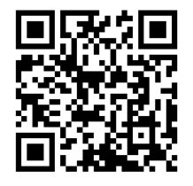
King bed/Twin bed | 2 persons | RMB 5,784
*includes:
- Two nights stay (check in Dec 11, check out Dec 13)
- Day skiing pass & equipment (boots, skis, poles) for one day
- Meals (full board): breakfast on Dec 12-13, lunch buffet on Dec 11-12, dinner on Dec 11-12 (Welcome Reception & Hüttenabend Gala Dinner)
- Access to conference on Dec 11
- Round-trip shuttle bus between Longjia Airport/Jilin Railway Station-Hotel (available only for selected departure times)

SHUTTLE BUSSES
Round-trip shuttle busses between Longjia Airport/Jilin Railway Station and Hotel are included in our booking package. If you need a shuttle bus, you must reserve a seat in the form below. The bus arrangement will be adjusted based on the registration situation.
Departure to Lake Songhua Seibu Prince Hotel
Recommended flights: Friday, December 11, CA1609, 07:15-09:00, Beijing Capital International Airport -Changchun Longjia International Airport, or CA1627, 09:40-11:40, Beijing Capital International Airport -Changchun Longjia International Airport
- I need a shuttle bus from Longjia Airport to Hotel at the following time on (Travel time around 1h30m):
deCEMBER 11, FRIday | Number of seats required
Departure 09:40
Pickup location: Lake Songhua Resort Reception Room, inside Exit 5 of Terminal 2
Departure 12:20
Pickup location: Lake Songhua Resort Reception Room, inside Exit 5 of Terminal 2
Recommended train: Thursday, December 10, G137, 13:55-18:26, Beijing Chaoyang-Jilin.
As traveling by train requires arrival one day in advance, please select one extra night when booking your hotel, or arrange your own accommodation in the Lake Songhua Resort area.
- I need a shuttle bus from Jilin Station to Hotel at the following time on (Travel time around 45m):
deCEMBER 10, thursday | Number of seats required
Departure 19:00
Departure point: Lake Songhua Shuttle Bus Stop, West Square of Jilin Railway Station, on the north side of the Days Hotel by Wyndham Jilin Railway Station.

Return from Lake Songhua Seibu Prince Hotel
Recommended trains: Sunday, December 13, G136, 10:59-15:32, Jilin- Beijing Chaoyang,
or G138, 15:11-19:44, Jilin- Beijing Chaoyang
- I need a shuttle bus from Hotel to Jilin Station at the following time on (Travel time around 45m):
deCEMBER 13, Sunday | Number of seats required
Departure 09:15
Departure 13:30
Recommended flights: Sunday, December 13, CA1628, 12:40-14:45, Changchun Longjia International Airport - Beijing Capital International Airport, or CA1650, 16:00-18:15, Changchun Longjia International Airport - Beijing Capital International Airport
- I need a shuttle bus from Hotel to Longjia Airport at the following time on (Travel time around 1h30m):
deCEMBER 13, sunday | Number of seats required
Departure 09:45
Departure 13:00

Ski Race powered by head Registration
Would you like to sign up for the ski race powered by HEAD on Saturday, December 12?
- No, I/we rather join the cheering crowd next to the finish line.
- Yes, I/we participate in the Ski Race powered by HEAD! I will use the separate race registration form to sign up.
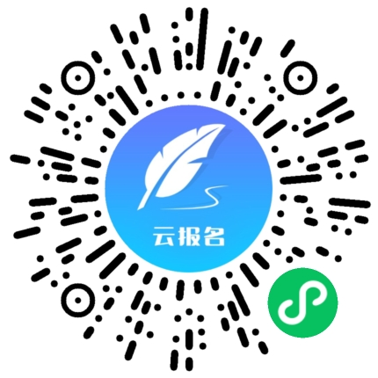

TERMS & CONDITIONS
I accept the following terms and conditions:
Only completed and signed booking forms can be accepted. ADVANTAGE AUSTRIA Beijing - Austrian Embassy Commercial Section reserves the right to decline registrations without explanation.
I have been informed that participation in the Austrian Winter Sports Day will require a stay at Lake Songhua Seibu Prince Hotel.
Participants acknowledge and accept the inherent risks associated with this activity. ADVANTAGE AUSTRIA Beijing - Austrian Embassy Commercial Section shall not be held liable for any personal injury or property damage arising from ordinary risks.

Date Signature
In order to register for the Austrian Winter Sports Days, please sign the completed booking form and return it by email to peking@advantageaustria.org by November 16th 2026. Successful registrations will be confirmed by email to the main contact person.

